
MATES Computer Science
Senior Capstone Project Bi-Weekly Progress Report - 2
Project Title | Project Egress
Team Members | Ethan Todd, Liam Bragg, Madeline Rosshirt
Dates Covered by Report | 03/03/26 to 03/06/26; 03/09/26 to 03/13/26; 03/16/26 to 03/20/26
Link to Github | https://github.com/Fennec427/Project-Egress

Summary of Project
Our project is called “Project Egress”. It is a 2-D puzzle platformer made in Unity with pixel art for graphics. Inspired by the video games Splatoon and Portal, the gameplay is centered around the use of different paint colors and their abilities across multiple levels of scaling difficulty. There will also be a variety of tools used to spread the paint. Levels will have stage elements such as spike traps or moving platforms to add a uniqueness to each level.

Summary of Progress this Period
This progress period was mainly focused on creation of player movement, sandbox, death and respawn, art, and creation of the first level. There were also quite a few bugs to patch (some go unmentioned as it was just the code itself not working and not working code with a bug). The thing that took the longest was definitely player movement as that has been constantly getting worked on since the branch was created. Death and Respawn took 3 days to get working. The first level only started to get worked on around the 2nd week due to Unity Hub not working on Ethan’s computer. Maddie also had to stop working on player movement for a bit due to Unity having two installations which made Liam who was working on Sandbox take over player movement and Maddie transitioning to death and respawn. The end of the 2nd week was mostly focused on bug fixes and discussions on how paint should work.

Detailed Progress this Period, separated by Team Member

Ethan: First, the project didn’t work for the first week. I didn’t notice it at first because I was working a little bit with the default sprites that are essentially finished for now. Until that Friday, in which Liam helped me get a new virtual machine that he and Maddie were using, I kept on trying to solve the issue of the project not working (which had no other clear solutions). The next week, I focused on actually starting to get the coding parts of the project. Monday I ended up mainly just installing Unity Hub and Unity Engine (which took a while and the entire block). After that, I started working on the jumping script to allow our character to jump and also only jump on the floor as the next couple days progressed. In my downtime, while things were loading, I made sure to work on some more of the sprites for our props and prefabs (that may end up being final). After I messed around with the code, at the end of the week, I started to work on the level creation parts of our project. It took me a couple of days to get the hang of how to work with the props and prefabs, but I think I understand them well for the most part now. After the week was over, I at least had a good idea of how the workspace and hierarchy worked. Now, transitioning into this week, I continued my progress and created a clear level outline to follow. During some downtime during each block, I started to do a little more planning with specifics. The first couple days of this week were slower as not only was the creation process slow, but there were also minor technical issues or hurdles that still popped up. I made sure to at least use my time wisely with other things I could do outside the virtual machine (i.e. the sprites and planning). Moving into recent progress, I have managed to figure out how to make a brush inside a tile map (although it took me a bit to figure out). This essentially allows me to paint the tiles directly onto the workspace in a much easier fashion. Now, I am preparing to continue our progress on our first level (which is mainly focused on platforming mechanics as opposed to our paints). Although I am not great with a lot of the technical aspects of our projects, I think I have managed pretty well so far.
Madeline: At first I started by trying to go into Unity which had updated between the time that I installed it and the other two installed it so I had to go and get the new version. After about a day or 2 I started the movement branch, added a box into the scene to stand on, and started coding it before Liam went home and decided to finish movement over the weekend. Then the day after I went and fixed the character rotating when they fell off the platform. I later made it so that the character is no longer static and cycles through all of their sprites (though I am not fully animating them since it is just a placeholder). I remember Liam and I going in and fixing something at the same time to try and get something to work (both of which he committed) but I don’t remember which commits they were. Around the same time I had to fix my previous Unity installation not uninstalling, causing the virtual machine to run slow. Afterwards I made a new branch where I was trying to get both death and respawn to work. By the first day I got death working. On the second day I broke death but got respawn working but it spawned in infinite copies when you go over a death hitbox. On the third day I fixed up everything and got both death and respawn working and merged it into FIrst Level and Sandbox. The following two days I was chatting with Liam brainstorming ways to get the paint working which we did come to a consensus on an idea. However I was messing around with player movement trying to see what bugs I could find while discussing and we got sidetracked trying to fix a bug instead of seeing if we could code the paint in the way we decided to. The bug was kind of really important to patch as it allowed for unintentional wall jumping which could make the player jump between walls unintentionally which after further messing around with it you were able to just jump up walls. The bug was kind of finicky but it was an important enough issue to fix. I thought that it might have been caused by a new mechanic that I suggested Liam to add in coyote time which was correct. (Just a quick side note coyote time is a technique used in games where the game will allow a brief grace period for the player to jump if they unintentionally fall off a platform referencing Wile E. Coyote in the Looney Tunes cartoon). After fixing coyote time all of the bugs were fixed. Throughout all of this I was mainly the one keeping the Trello board up to date though Liam did add a card or two while trying to fix bugs.
Liam: For the first week or so, I continued to help my group members with their virtual machines. I made most of the player movement. I added systems common to other platforming-type games such as coyote time, also known as late jumps, and input buffering, for early button presses (although it only applies to jumping for now). Multiple problems were found with jumping that were fixed, such as the Up arrow or W keys not registering as jumps or having the ability to be able to jump off of nothing when moving into a wall. I was the one who did all the merges, most notably moving any changes to player movement from the player-movement branch into the other branches. The main reason why I have not merged anything into the main branch is because neither the sandbox or the first level branches are ready to be pushed into main just yet, and the user would have nothing to move or jump on if only the player-movement branch were to be merged. I also add any sprites that Ethan sends over, typically adding them to the sandbox branch and merging with other branches as needed. Occasionally, I will work at home, whether it’s something I didn’t finish in class or my group members need help getting something to work.

Difficulties Encountered this Progress Period
The virtual machines were generally slow still (although not horrible at all). The biggest difficulty during this progress period was the project in Unity Engine not loading properly when added. At least visually, it looked like the download was good in Unity Hub, but when trying to actually load the project itself, an error occurred. The only fix Ethan and Liam could think of for this issue is to just get a new virtual machine as it seems like Unity Engine will only partially download sometimes (even though it looks like it downloads fully). Once Ethan got the new virtual machine, although slow with download speed, Unity Engine worked properly and the project loaded. Other smaller difficulties include small technical mistakes (caused by user error usually) such as not checking if the internet is connected properly (which is an issue on Ethan’s virtual machine) or not creating something properly in Unity Engine itself. The former is more confusing as it only happens on Ethan’s virtual machine where it has to have the internet manually turned on. Other than that, it’s mainly just the learning process. Liam’s virtual machine has a similar problem where the virtual machine has no internet, which appears to only be solvable by restarting the host machine.

Updated Trello Board and Discussion
https://trello.com/b/D29yQgac/project-egress
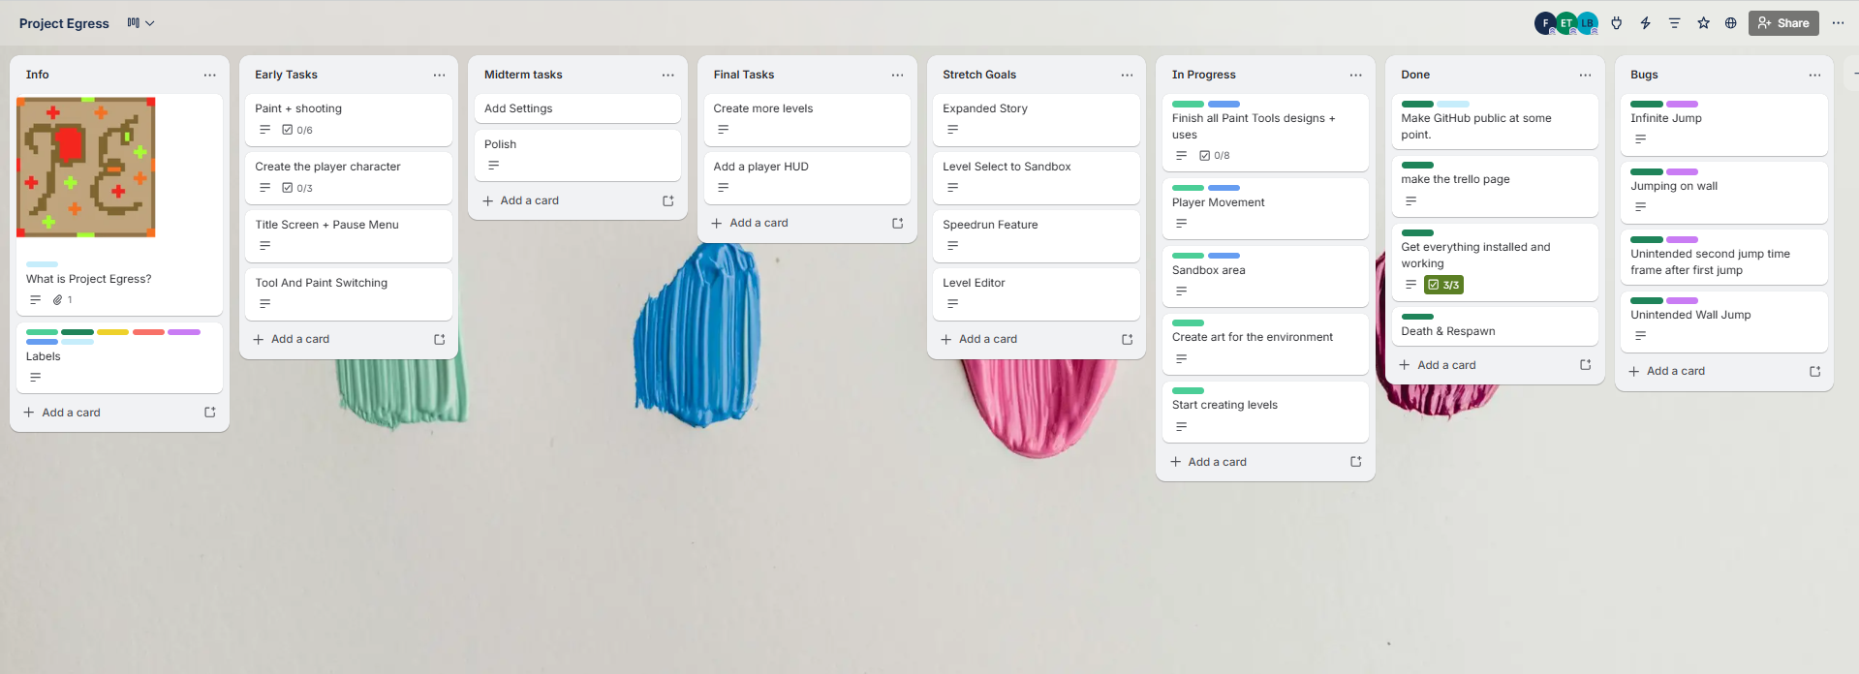
We have the new “Bugs” category and label. Maddie also added a few new tasks which are mostly ones she just forgot on her initial creation of the board. Another thing is that Player Movement and Sandbox Area have been changed to the “Throughout Project” label due to the paint requiring updates to movement and the sandbox needing to be updated periodically to test new things (like the different paint and tools). Other than that just found and patched a few bugs and some things are completed now.

Tasks to Be Worked on in Next Progress Period
Now that basic movement is done (for now), we can start moving on to the meat of the project (the paint mechanic itself). The sandbox still needs to be worked on more to have space to test out new mechanics. Mainly, Ethan is trying to focus on some of the level creation and sandbox creation (possibly) and the shells of the levels themselves while also briefly working on some new sprites in between or during any downtime. Liam and Maddie will focus on getting the paint and shooting working as it is going to be quite a big task to accomplish. If there is any extra time where there is nothing Maddie can help with she will either start working on the paint + tool swap mechanic or a simple pause screen which can be updated later.

Additional Information

